Mutation Testing

Submitted By Abhishek Rauthan MT2023106
Sankalp Rai MT2023150

Repository link-https://github.com/AbhishekRauthan909/Mutation-Testing

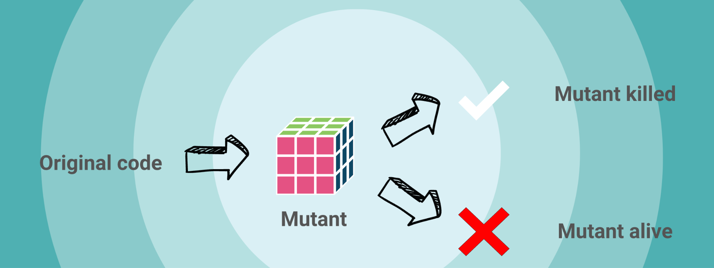

Introduction

Mutation testing is a software testing technique where small modifications, called "mutations," are introduced to the program's code to check if the existing test suite can detect the changes. The goal is to evaluate the effectiveness of the tests by ensuring they can identify faults or errors. If a mutation goes undetected, it indicates that the test suite may need improvement. This technique helps assess the robustness and quality of tests.Mutation testing is a white box testing.

Why Mutation Testing?

Traditional test coverage metrics like line, statement, and branch coverage measure what code is executed during testing, but they don’t ensure that the tests can detect faults in the code. These metrics only show which parts of the code are tested, not whether the tests are effective at finding errors. Mutation testing improves on this by introducing small changes (mutations) to the code and checking if the tests can catch them, providing a better measure of test effectiveness.

Tools Used

Java (PIT)

PIT is a state of the art mutation testing system, providing gold standard test coverage for Java and the jvm. It's fast, scalable and integrates with modern test and build tooling.PIT runs our unit tests against automatically modified versions of your application code. When the application code changes, it should produce different results and cause the unit tests to fail. If a unit test does not fail in this situation, it may indicate an issue with the test suite.

Objective of Mutation Testing

The objective of mutation testing is

- To identify pieces of code that are not tested properly.
- To identify hidden defects that can’t be defected using other testing methods.
- To discover new kinds of errors or bugs.
- To assess the quality of the test cases.

How it works

Mutation testing works by introducing small changes, called mutations, to the program's source code to simulate potential faults.
Here’s how it works-

Create Mutants: The original code is altered in various ways (e.g., changing arithmetic operators, flipping conditions, or modifying constants) to create multiple mutant versions of the code.
Run Tests: The test suite is then executed against each mutant.
Evaluate Test Effectiveness: If the test suite detects the mutation (i.e., the mutant causes the test to fail), the mutation is "killed." If the test suite doesn't catch the mutation, the mutant survives.
Assess Test Quality: The goal is to measure how many mutants are killed, indicating how well the test suite detects errors and potentially revealing areas of the code that need better testing.
The higher the mutation kill rate, the more effective the test suite is in detecting faults.

Levels of Mutation Testing

Mutation testing can be categorized into Unit Mutation and Integration Mutation based on the scope and the level of the code being mutated.

    - Unit Mutation

Unit mutation focuses on testing individual units (usually functions or methods) in isolation.Small changes are introduced to the code of individual units (e.g., changing variables, operators, or conditions inside a single function). The test suite for that specific unit is executed to check if it can detect these changes. It aims to test the correctness of each isolated unit's behavior and ensures that unit tests can detect faults within the unit itself.
For example Changing an arithmetic operator in a method or swapping the logic of a conditional statement in a function.

    - Integration Mutation

Integration mutation focuses on testing interactions between different units or components within the system.Mutations are applied at the integration points between components or modules, such as method calls, data exchanges, or interfaces between modules.It checks whether the integration of components works correctly and ensures that integration tests can detect faults in the communication and interaction between different parts of the system.
For example Changing the way data is passed between methods or altering the interaction between integrated modules.

Mutation Score

Mutation Score is a metric used in mutation testing to evaluate the effectiveness of a test suite in detecting faults introduced by mutations in the code.

Mutation Score= (Destroyed Mutants) / (Total Number of Mutants) *100.

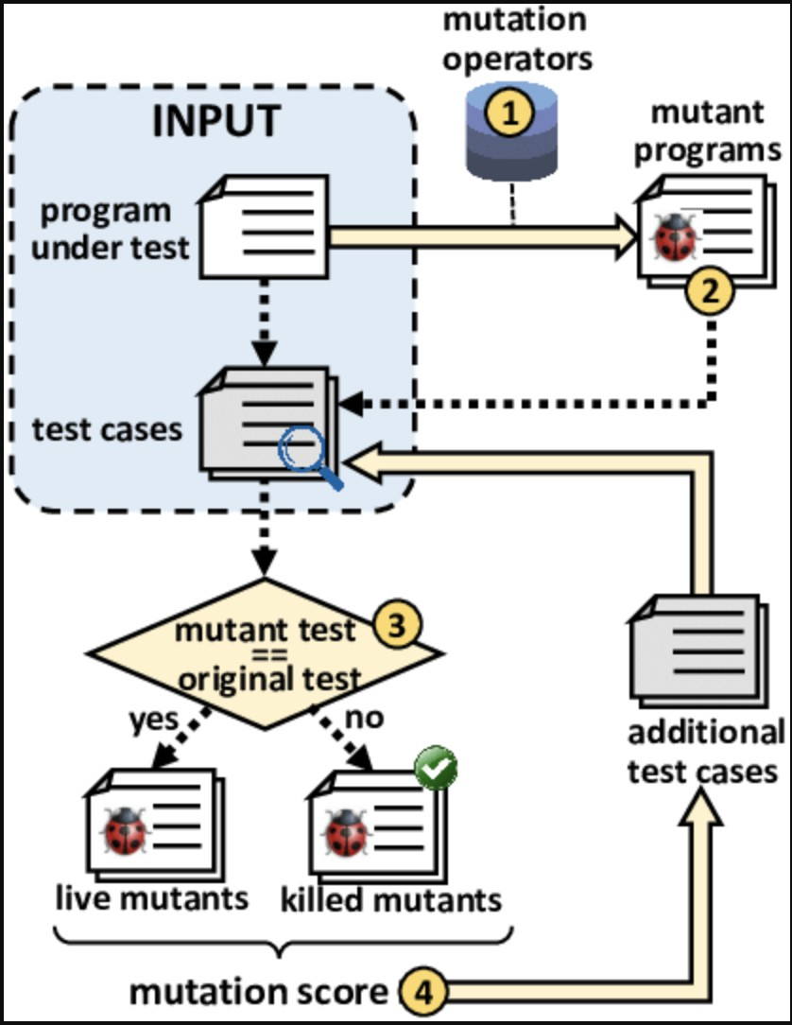

Source Code

Our code is a collection of functions. We have used different kinds of functionality like MathUtility, Employee, Bank Management,E-commerce services.
Total Lines ~ 1100 lines.

We have write manual unit test cases for MathUtility,Employee and Bank Management functions and integration test cases for E-commerce services.
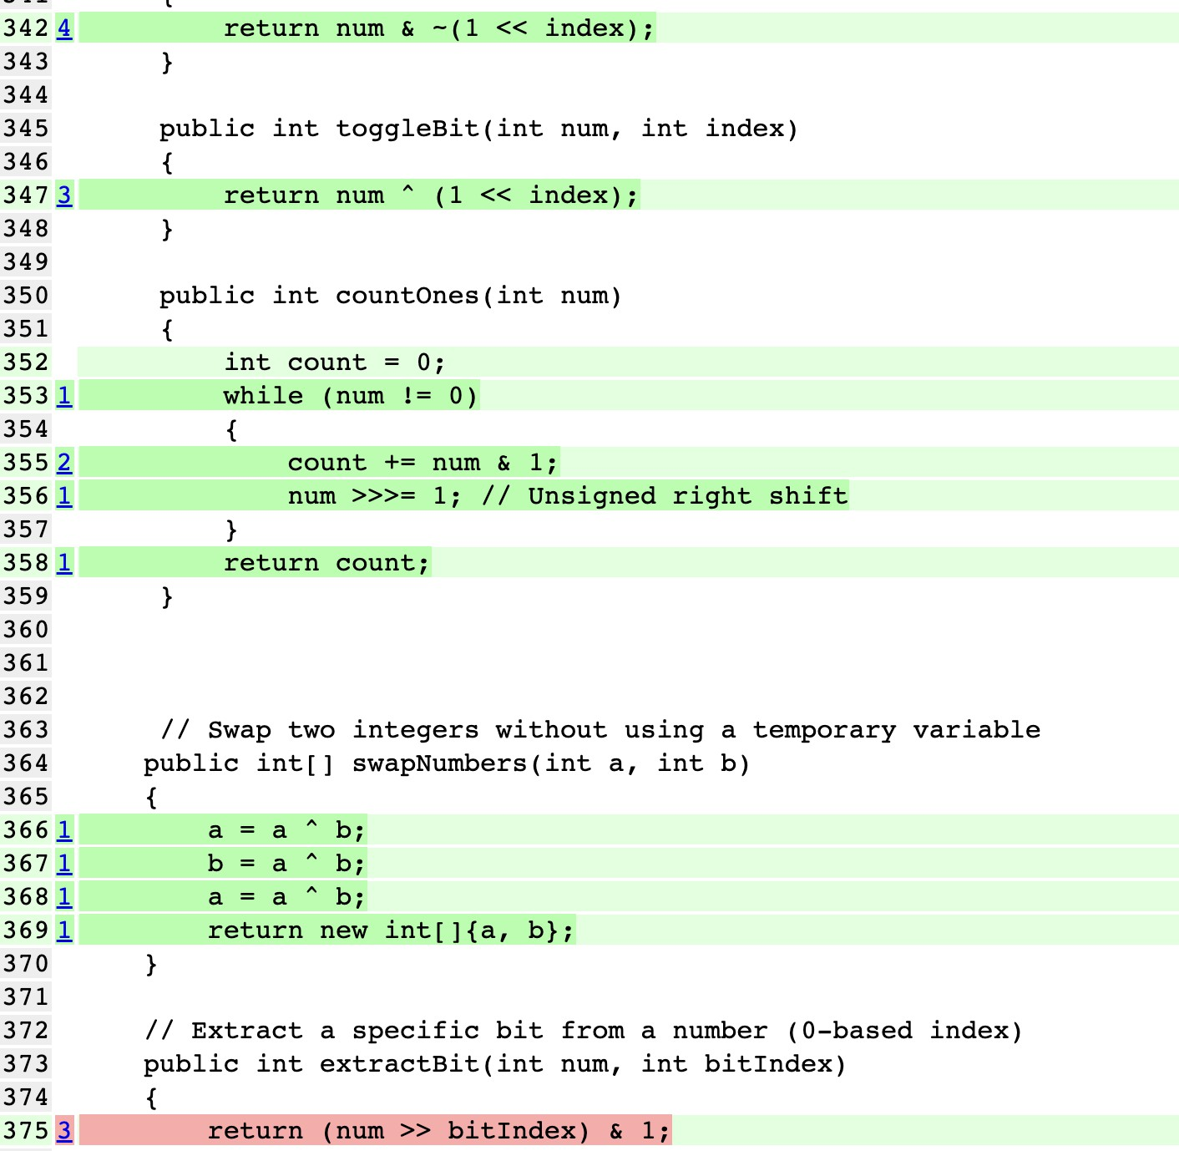

Fig 1 Our code snippet

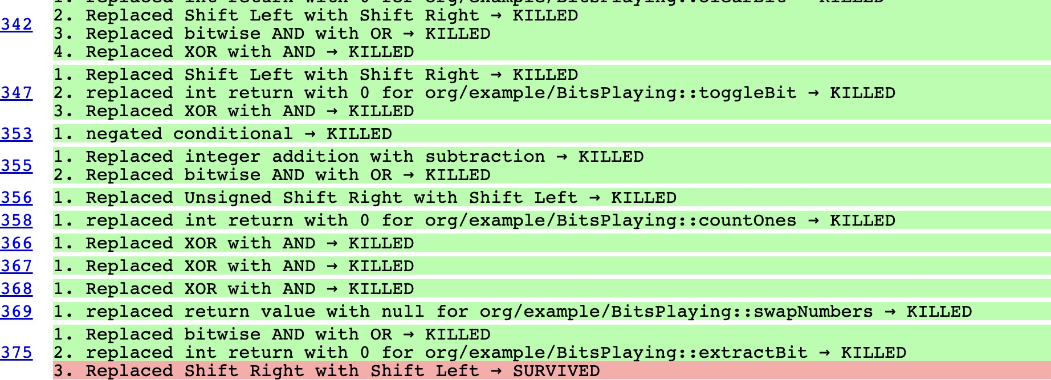

Fig 2 Mutation Testing

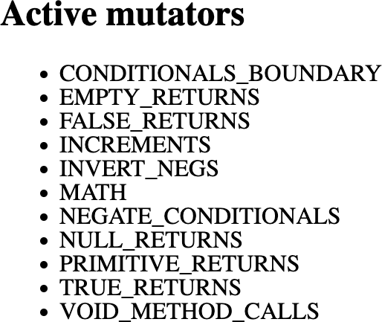

- Result

